MINISTRY OF SCIENCE, HIGHER EDUCATION AND INNOVATIONS
OF THE KYRGYZ REPUBLIC

KYRGYZ STATE TECHNICAL UNIVERSITY named after I.Razzakov

INSTITUTE OF INFORMATION TECHNOLOGIES
DEPARTMENT OF “SOFTWARE OF COMPUTEER SYSTEMS”
710400 “Software Engineering” in English.

Term project

For the course: Database Management Systems
On the topic: Development of a web application for a car manufacturing
enterprise

Prepared by:
Student of group SE(Eng)-2-23
Batyrova A.K.

Instructor:
Abalieva A.D.
Senior Lecturer

Bishkek, 2026
Table of Content

1.Technical Specification 2
1.1. Introduction 2
1.2. Objective of the Work 2
1.3. Problem Specification 2
1.4. Purpose and Goals of System Creation 2
1.5. Functional Requirements 2
1.6. Client-Side Requirements 2
2. Server Side 2
2.1. Database 2
2.2. Tables 2
2.3. Stored Procedures 2
2.4. Scalar Functions 2
2.5. Triggers 2
3. Client Side 2
3.1. Description of Project Creation 2
3.2. Detailed Analysis (Entity, Controller, Service, Repository, View) 2
4. Launching the program 2
5. Screenshots of the program 2
6. Conclusion 2
7. List of Used Literature 2
8. Application appendix 2

1. Technical Specification
1.1. Introduction
In the context of the modern manufacturing market, effective enterprise resource management is becoming a key factor for business success. Car manufacturing companies face the need not only to control production processes but also to maintain financial discipline, manage personnel, control procurement of raw materials, and monitor sales of finished products.
The web application for the car manufacturing enterprise was developed to address the absence of a unified digital management system. Without such a system, the company was unable to efficiently track budget performance, manage credit obligations, maintain accurate employee records with salary payments, control raw material procurement, and manage the product line. Implementing this web application is a relevant task that will enable the enterprise to operate more efficiently and make data-driven decisions.
1.2. Objective of the Work
The objective of the work is to develop and implement a comprehensive web application for a car manufacturing enterprise. The main task is to create tools that will enable authorized users to:
- View and manage the enterprise budget;
- Record and track credits and loan repayments;
- Manage employees, their positions, and salary payments;
- Track raw material procurement;
- Manage the finished product line, production records, and sales.
1.3. Problem Specification
During the analysis of the existing management processes of the car manufacturing enterprise, the following problems were identified:
- Absence of a unified budget accounting tool, making it difficult to track income and expenses.
- Lack of a system for credit management, leading to difficulties in monitoring repayment schedules.
- Absence of automated employee management, which complicated salary processing.
- No system for raw material procurement tracking, making it difficult to control inventory.
- Lack of a digital tool for managing the finished product line and production records.
1.4. Purpose and Goals of System Creation
1.4.1. Purpose
Development of a web application for the management of a car manufacturing enterprise:
- Providing managers and accountants with effective tools for comprehensive enterprise resource management.
- Simplifying the processes of budget control, credit tracking, personnel management, procurement, and sales.
1.4.2. Goals
The main goals of creating the new system are:
- Simplify the process of budget accounting and financial planning.
- Ensure quick access to information about credits and their repayment status.
- Automate employee management, salary payments, and position tracking.
- Provide transparent control over raw material procurement.
- Enable efficient management of the finished product line, production, and sales.
1.5. Functional Requirements
- Creating and editing budget records.
- Viewing budget history.
- Recording credits and scheduling repayments.
- Tracking credit repayment status.
- Creating, editing, and viewing employee records.
- Processing salary payments and tracking job positions.
- Recording raw material purchases.
- Managing the finished product line (creation, editing, production records).
- Recording and viewing sales of finished products.
- Automatically updating the budget after purchases, sales, credit operations, and salary payments.
- Checking the availability of raw materials before product production.
- Preventing the sale of products below their calculated cost.
- Generating PDF reports for selected business operations (via web interface).
- Module 2: Automatic raw material procurement when materials are insufficient for production.
1.6. Client-Side Requirements
- The client can use one of the following web browsers:
- Google Chrome
- Yandex Browser
- Mozilla Firefox
- Microsoft Edge
- To use the system, the user must authenticate (basic session management).
- The user interface should be simple, clear, and convenient for daily work.
- The main pages of the application must be accessible through the navigation sidebar.
- The system should display important information, such as the current budget and the authorized user, in a visible area of the interface.
- The client side should allow users to work with forms, tables, buttons, and dynamically rendered data.
- Pages should support basic operations such as adding new records (purchases, production, sales), viewing operation history, and generating reports.
- Error messages should be displayed in a user-friendly way when a business rule is violated, for example when the budget is not enough or when raw materials are insufficient for production.
2. Server Side
2.1. Database
The database consists of 13 tables (including reference tables), 5 stored procedures, 1 scalar function, and 2 triggers. The database is implemented in Microsoft SQL Server and accessed via ODBC from the Flask application.
Database name: CarManufacturing
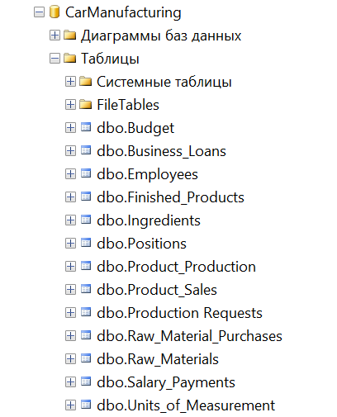
Image 1. The List of All Tables in DB.
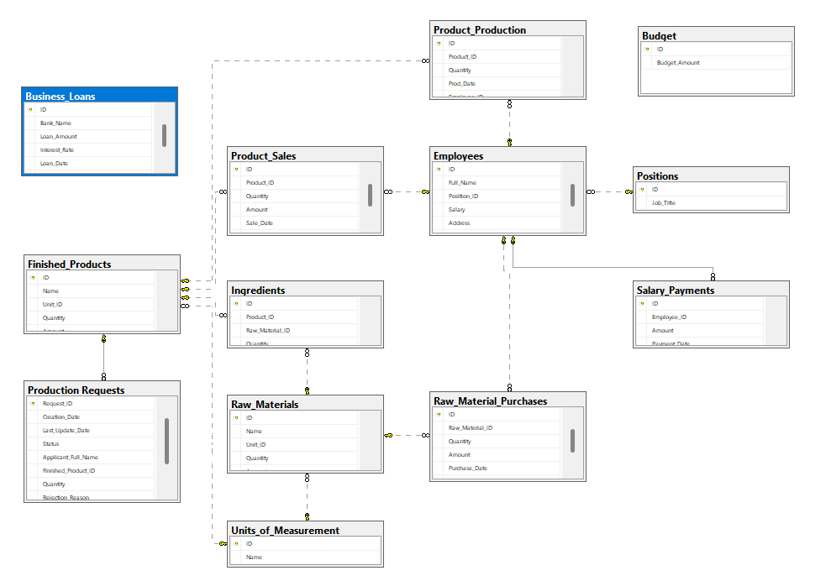
Image 1.5 Database diagram
2.2. Tables
1. "Budget" Table is intended to store the current budget amount of the enterprise.
Table structure :
- ID - int data type, the Primary Key (always 1).
- Budget_Amount - money data type, the current budget amount of the enterprise in KGS.
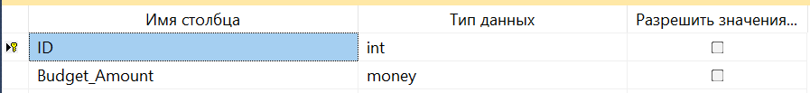
Image 2. Project of the table "Budget"
2. "Business_Loans" Table is intended to store information about bank loans taken by the enterprise.
Table structure :
- ID - int data type, the Primary Key.
- Bank_Name - nvarchar(100) data type, the name of the bank that issued the loan.
- Loan_Amount - money data type, the principal amount of the loan.
- Interest_Rate - float data type, the annual interest rate in percent.
- Loan_Date - datetime data type, the date when the loan was taken.
- Status - nvarchar(50) data type, the current status of the loan ('Active' or 'Repaid').
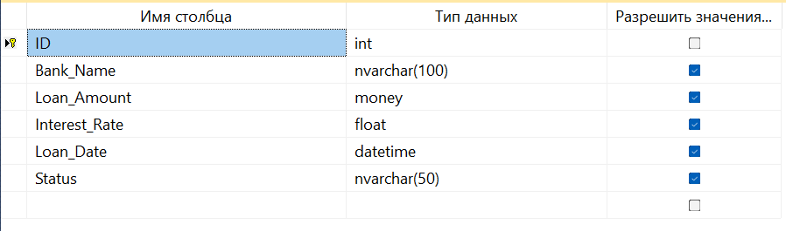
Image 3. Project of the table "Business_Loans"
3. "Employees" Table is intended to store information about employees.
Table structure :
- ID - int data type, the Primary Key.
- Full_Name - nvarchar(100) data type, the full name of the employee.
- Position_ID - int data type, foreign key referencing the position in the Positions table.
- Salary - money data type, the employee's monthly salary.
- Address - nvarchar(200) data type, the residential address of the employee.
- Phone - nvarchar(50) data type, the contact phone number.
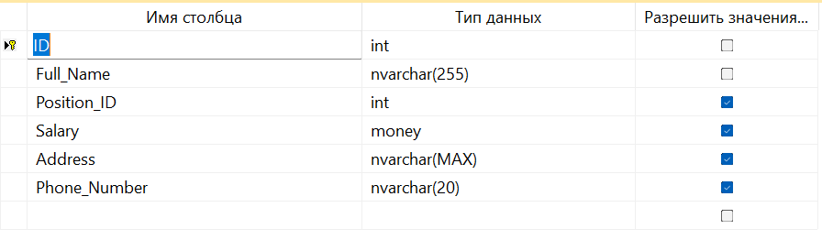
Image 4. Project of the table "Employees"

4. "Positions" Table is intended to store the list of job positions.
Table structure :
- ID - int data type, the Primary Key.
- Job_Title - nvarchar(100) data type, the title of the position (e.g., Director, Engineer, Manager).
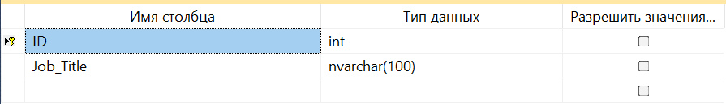
Image 5. Project of the table "Positions"
5. "Salary_Payments" Table is intended to store records of salary payments made to employees.
Table structure :
- ID - int data type, the Primary Key.
- Employee_ID - int data type, foreign key referencing the employee receiving the payment.
- Amount - money data type, the salary amount paid.
- Payment_Date - datetime data type, the date of the payment.
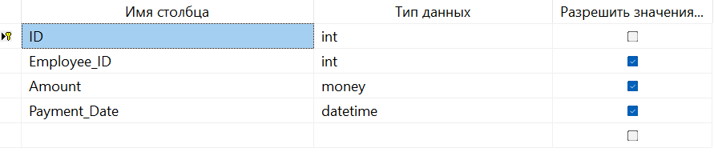
Image 6. Project of the table "SalaryPayments"
6. "Raw_Materials" Table is intended to store information about raw materials used in production.
Table structure :
- ID - int data type, the Primary Key.
- Name - nvarchar(100) data type, the name of the raw material.
- Unit - nvarchar(20) data type, the unit of measurement (e.g., kg, pcs, liters).
- Quantity - float data type, the current stock quantity of the raw material.
- Amount - money data type, the total value of the stock.
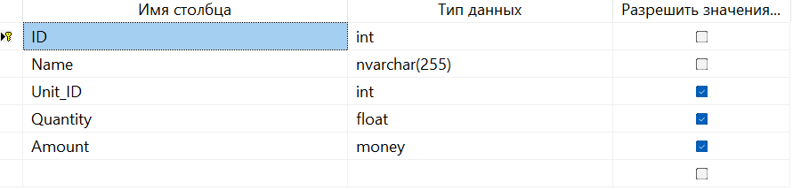
Image 7. Project of the table "RawMaterials"
7. "Finished_Products" Table is intended to store information about finished goods (car models).
Table structure :
- ID - int data type, the Primary Key.
- Name - nvarchar(100) data type, the name of the finished product / car model.
- Quantity - int data type, the current stock quantity of the finished product.
- Amount - money data type, the total value of the finished goods stock.
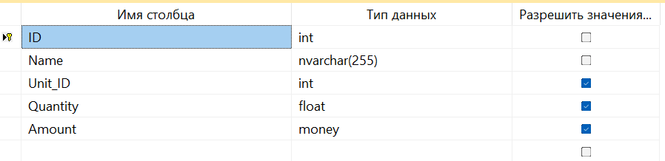
Image 8. Project of the table "FinishedProducts"
8. "Ingredients" Table is intended to store recipes (Bill of Materials) defining which raw materials are required for each finished product.
Table structure :
- ID - int data type, the Primary Key.
- Product_ID - int data type, foreign key referencing the finished product.
- Raw_Material_ID - int data type, foreign key referencing the raw material.
- Quantity - float data type, the amount of raw material required per unit of finished product.
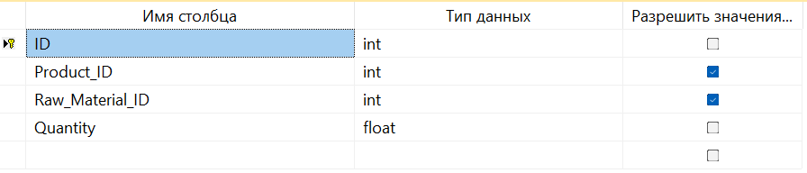
Image 9. Project of the table "Ingredients"
9. "Product_Production" Table is intended to record production events of finished products.
Table structure :
- ID - int data type, the Primary Key.
- Product_ID - int data type, foreign key referencing the finished product.
- Quantity - int data type, the produced quantity.
- Prod_Date - datetime data type, the production date.
- Employee_ID - int data type, foreign key referencing the employee responsible for production.
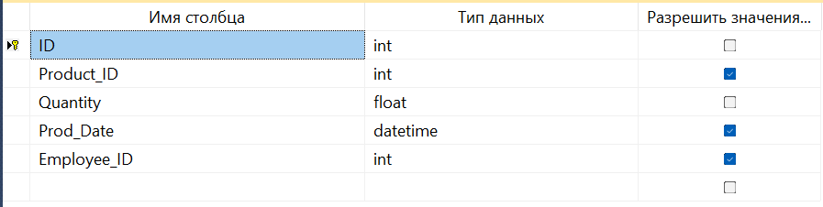
Image 10. Project of the table “ProductProduction”
10. "Raw_Material_Purchases" Table is intended to record purchases of raw materials.
Table structure :
- ID - int data type, the Primary Key.
- Raw_Material_ID - int data type, foreign key referencing the raw material purchased.
- Quantity - float data type, the purchased quantity.
- Amount - money data type, the total purchase amount.
- Purchase_Date - datetime data type, the purchase date.
- Employee_ID - int data type, foreign key referencing the employee who processed the purchase.
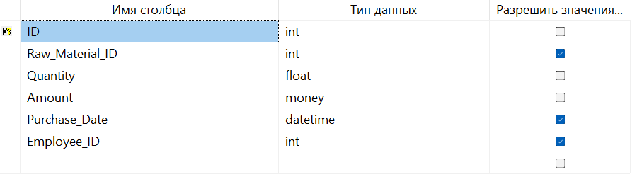
Image 11. Project of the table "Raw_Material_Purchases"
11. "Product_Sales" Table is intended to record sales of finished products.
Table structure :
- ID - int data type, the Primary Key.
- Product_ID - int data type, foreign key referencing the finished product sold.
- Quantity - int data type, the sold quantity.
- Amount - money data type, the total sale amount.
- Sale_Date - datetime data type, the sale date.
- Employee_ID - int data type, foreign key referencing the employee who processed the sale.
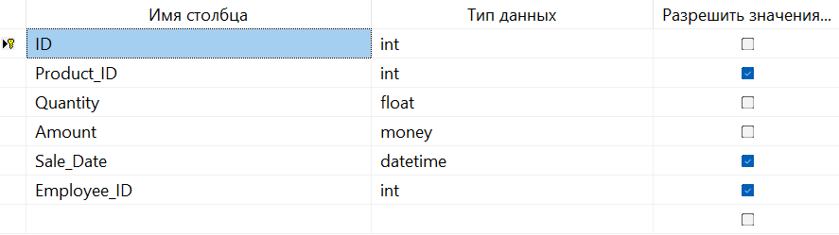
Image 12. Project of the table "ProductSales"
12. "Units_of_Measurement" Table
is intended to store the reference list of measurement units.
Table structure :
- ID - int data type, the Primary Key.
- Name - nvarchar(50) data type, the name of the unit (e.g., kg, pcs, liters).
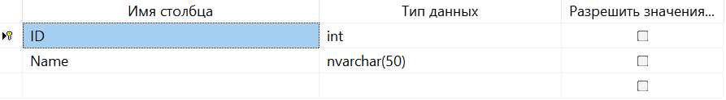
Image 13. Project of the table "UnitsOfMeasurement"
13. "Production Requests" Table (Module 2)
is intended to store automatic production requests that combine procurement, production, and sale into one workflow.
Table structure :
- Request_ID - int data type, the Primary Key (identity).
- Creation_Date - datetime data type, the date and time when the request was created.
- Last_Update_Date - datetime data type, the date and time when the request status was last updated.
- Status - nvarchar(100) data type, the current status (Created, Under raw material availability check, In the process of raw material procurement, In the production process, In the sales process, Completed, Error).
- Applicant_Full_Name - nvarchar(200) data type, the full name of the person who submitted the request.
- Finished_Product_ID - int data type, foreign key referencing the product to be produced.
- Quantity - int data type, the requested quantity to produce.
- Rejection_Reason - nvarchar(500) data type, the error message if the request failed.
- Error_Stage - nvarchar(100) data type, the stage at which the error occurred (Procurement, Production, Sales).
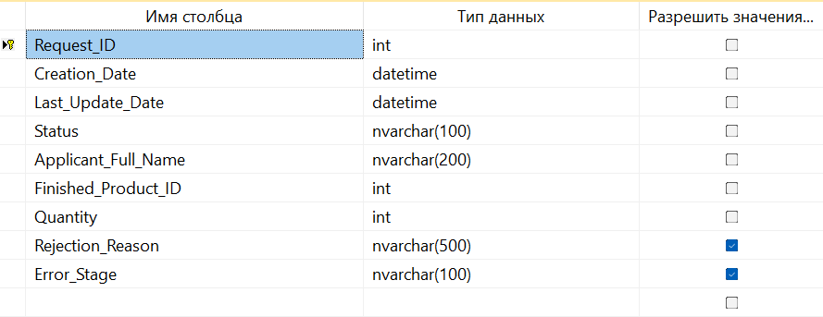
Image 14. Project of the table "Production Requests"

2.3. Stored Procedures
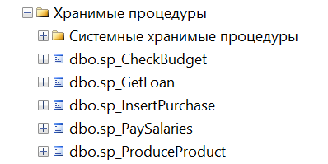
Image 15. List of Stored Procedures in DB.
There are 5 user-defined stored procedures in the database. They are used for the main database operations: checking budget, taking loans, inserting purchases, paying salaries, and producing products. These procedures help keep the database logic more organized and make it easier for the Flask application to work with important data operations.
sp_CheckBudget | ALTER PROCEDURE [dbo].[sp_CheckBudget]  @PurchaseAmount MONEY,  @Result INT OUTPUT  AS  BEGIN  SET NOCOUNT ON;  IF @PurchaseAmount IS NULL OR @PurchaseAmount < 0  BEGIN  SET @Result = 1;  SELECT @Result AS Result;  RETURN;  END;  IF COALESCE((SELECT Budget_Amount FROM dbo.Budget WHERE ID = 1), 0) >= @PurchaseAmount  SET @Result = 0;  ELSE  SET @Result = 1;  SELECT @Result AS Result;  END | Takes a purchase amount and returns 0 if budget is sufficient, 1 otherwise.
sp_GetLoan | ALTER PROCEDURE [dbo].[sp_GetLoan]  @BankName NVARCHAR(100),  @Amount MONEY,  @Rate FLOAT,  @Result INT OUTPUT  AS  BEGIN  SET NOCOUNT ON;  IF NULLIF(LTRIM(RTRIM(@BankName)), '') IS NULL OR @Amount IS NULL OR @Amount <= 0  BEGIN  SET @Result = 1;  SELECT @Result AS Result;  RETURN;  END;  INSERT INTO dbo.Business_Loans (Bank_Name, Loan_Amount, Interest_Rate, Loan_Date, Status)  VALUES (@BankName, @Amount, @Rate, GETDATE(), 'Active');  UPDATE dbo.Budget SET Budget_Amount = Budget_Amount + @Amount WHERE ID = 1;  SET @Result = 0;  SELECT @Result AS Result;  END | Inserts a loan record and adds the amount to the budget.
Sp_InsertPurchase | ALTER PROCEDURE [dbo].[sp_InsertPurchase]  @MaterialID INT,  @Qty FLOAT,  @Amount MONEY,  @EmpID INT,  @Result INT OUTPUT  AS  BEGIN  SET NOCOUNT ON;  IF @Qty IS NULL OR @Qty <= 0 OR @Amount IS NULL OR @Amount <= 0  BEGIN  SET @Result = 2;  SELECT @Result AS Result;  RETURN;  END;  IF NOT EXISTS (SELECT 1 FROM dbo.Raw_Materials WHERE ID = @MaterialID)  BEGIN  SET @Result = 3;  SELECT @Result AS Result;  RETURN;  END;  IF NOT EXISTS (SELECT 1 FROM dbo.Employees WHERE ID = @EmpID)  BEGIN  SET @Result = 4;  SELECT @Result AS Result;  RETURN;  END;  DECLARE @BudgetCheck INT;  EXEC dbo.sp_CheckBudget @Amount, @BudgetCheck OUTPUT;  IF @BudgetCheck = 0  BEGIN  INSERT INTO dbo.Raw_Material_Purchases (Raw_Material_ID, Quantity, Amount, Purchase_Date, Employee_ID)  VALUES (@MaterialID, @Qty, @Amount, GETDATE(), @EmpID);  SET @Result = 0;  END  ELSE  SET @Result = 1;  SELECT @Result AS Result;  END | Validates input, checks budget, and records a purchase if funds are sufficient. Return codes: 0=success, 1=insufficient budget, 2=invalid input, 3=material not found, 4=employee not found.
sp_PaySalaries | ALTER PROCEDURE [dbo].[sp_PaySalaries]  @Result INT OUTPUT  AS  BEGIN  SET NOCOUNT ON;  DECLARE @TotalSalary MONEY;  SELECT @TotalSalary = COALESCE(SUM(Salary), 0) FROM dbo.Employees;  DECLARE @BudgetCheck INT;  EXEC dbo.sp_CheckBudget @TotalSalary, @BudgetCheck OUTPUT;  IF @BudgetCheck = 0  BEGIN  UPDATE dbo.Budget SET Budget_Amount = Budget_Amount - @TotalSalary WHERE ID = 1;  INSERT INTO dbo.Salary_Payments (Employee_ID, Amount, Payment_Date)  SELECT ID, Salary, GETDATE() FROM dbo.Employees;  SET @Result = 0;  END  ELSE  SET @Result = 1;  SELECT @Result AS Result, @TotalSalary AS TotalSalary;  END | Calculates total salary, checks budget, deducts from budget, and records individual salary payments.
sp_ProduceProduct | ALTER PROCEDURE [dbo].[sp_ProduceProduct]  @ProductID INT,  @Quantity INT,  @EmployeeID INT,  @ProductionCost MONEY OUTPUT,  @Result INT OUTPUT  AS  BEGIN  SET NOCOUNT ON;  SET @ProductionCost = 0;  IF @Quantity IS NULL OR @Quantity <= 0  BEGIN  SET @Result = 4;  SELECT @Result AS Result, @ProductionCost AS ProductionCost;  RETURN;  END;  IF NOT EXISTS (SELECT 1 FROM dbo.Finished_Products WHERE ID = @ProductID)  BEGIN  SET @Result = 5;  SELECT @Result AS Result, @ProductionCost AS ProductionCost;  RETURN;  END;  IF NOT EXISTS (SELECT 1 FROM dbo.Ingredients WHERE Product_ID = @ProductID)  BEGIN  SET @Result = 3;  SELECT @Result AS Result, @ProductionCost AS ProductionCost;  RETURN;  END;  IF EXISTS (  SELECT 1  FROM dbo.Ingredients i  JOIN dbo.Raw_Materials rm ON i.Raw_Material_ID = rm.ID  WHERE i.Product_ID = @ProductID  AND COALESCE(rm.Quantity, 0) < i.Quantity * @Quantity  )  BEGIN  SET @Result = 1;  SELECT @Result AS Result, @ProductionCost AS ProductionCost;  RETURN;  END;  SET @ProductionCost = dbo.fn_CalculateProductionCost(@ProductID, @Quantity);  DECLARE @BudgetCheck INT;  EXEC dbo.sp_CheckBudget @ProductionCost, @BudgetCheck OUTPUT;  IF @BudgetCheck = 1  BEGIN  SET @Result = 2;  SELECT @Result AS Result, @ProductionCost AS ProductionCost;  RETURN;  END;  UPDATE rm  SET rm.Quantity = rm.Quantity - i.Quantity * @Quantity,  rm.Amount = CASE  WHEN rm.Amount - (i.Quantity * @Quantity * CASE WHEN rm.Quantity > 0 THEN rm.Amount / rm.Quantity ELSE 0 END) < 0 THEN 0  ELSE rm.Amount - (i.Quantity * @Quantity * CASE WHEN rm.Quantity > 0 THEN rm.Amount / rm.Quantity ELSE 0 END)  END  FROM dbo.Raw_Materials rm  JOIN dbo.Ingredients i ON rm.ID = i.Raw_Material_ID  WHERE i.Product_ID = @ProductID;  UPDATE dbo.Budget  SET Budget_Amount = Budget_Amount - @ProductionCost  WHERE ID = 1;  UPDATE dbo.Finished_Products  SET Quantity = COALESCE(Quantity, 0) + @Quantity,  Amount = COALESCE(Amount, 0) + @ProductionCost  WHERE ID = @ProductID;  INSERT INTO dbo.Product_Production (Product_ID, Quantity, Prod_Date, Employee_ID)  VALUES (@ProductID, @Quantity, GETDATE(), @EmployeeID);  SET @Result = 0;  SELECT @Result AS Result, @ProductionCost AS ProductionCost;  END | Checks raw material availability using BOM, calculates production cost, consumes materials, deducts cost from budget, increases finished goods stock, and records the production event. Return codes: 0=success, 1=insufficient raw materials, 2=insufficient budget, 3=no BOM, 4=invalid quantity, 5=product not found.

2.4. Scalar Functions
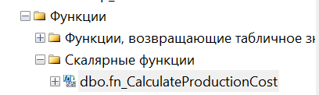
Image 16. List of Scalar Functions in DB.
CalculateProductionCost | ALTER FUNCTION [dbo].[fn_CalculateProductionCost]  (  @ProductID INT,  @Quantity INT  )  RETURNS MONEY  AS  BEGIN  DECLARE @Cost MONEY;  SELECT @Cost = COALESCE(SUM(  CAST(i.Quantity AS DECIMAL(18,4)) * CAST(@Quantity AS DECIMAL(18,4)) *  CASE  WHEN rm.Quantity > 0 THEN CAST(rm.Amount AS DECIMAL(18,4)) / NULLIF(CAST(rm.Quantity AS DECIMAL(18,4)), 0)  WHEN rm.Amount > 0 THEN CAST(rm.Amount AS DECIMAL(18,4))  ELSE 0  END  ), 0)  FROM dbo.Ingredients i  JOIN dbo.Raw_Materials rm ON rm.ID = i.Raw_Material_ID  WHERE i.Product_ID = @ProductID;  RETURN @Cost;  END | Iterates through all ingredients of a product, calculates the cost of each raw material needed (quantity × per-unit cost), and returns the total production cost.

2.5. Triggers
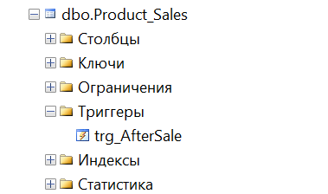  Image 17. Trigger for table |  | 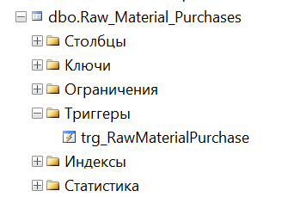  Image 18. Trigger for table
Name | Code |  | Description
trg_AfterSale | ALTER TRIGGER [dbo].[trg_AfterSale]  ON [dbo].[Product_Sales]  AFTER INSERT  AS  BEGIN  SET NOCOUNT ON;  IF EXISTS (SELECT 1 FROM inserted WHERE Quantity <= 0 OR Amount <= 0)  BEGIN  RAISERROR('Sale quantity and amount must be greater than zero.', 16, 1);  ROLLBACK TRANSACTION;  RETURN;  END;  IF EXISTS (  SELECT 1  FROM (  SELECT Product_ID, SUM(Quantity) AS Quantity  FROM inserted  GROUP BY Product_ID  ) s  JOIN dbo.Finished_Products fp ON fp.ID = s.Product_ID  WHERE COALESCE(fp.Quantity, 0) < s.Quantity  )  BEGIN  RAISERROR('Insufficient finished product stock for sale.', 16, 1);  ROLLBACK TRANSACTION;  RETURN;  END;  UPDATE fp  SET fp.Quantity = fp.Quantity - s.Quantity  FROM dbo.Finished_Products fp  JOIN (  SELECT Product_ID, SUM(Quantity) AS Quantity  FROM inserted  GROUP BY Product_ID  ) s ON s.Product_ID = fp.ID;  UPDATE dbo.Budget  SET Budget_Amount = Budget_Amount + (SELECT SUM(Amount) FROM inserted)  WHERE ID = 1;  END |  | Validates sale data, checks finished product availability, decreases stock, and adds revenue to the budget.
trg_RawMaterial Purchase | ALTER TRIGGER [dbo].[trg_RawMaterialPurchase]  ON [dbo].[Raw_Material_Purchases]  AFTER INSERT  AS  BEGIN  SET NOCOUNT ON;  IF EXISTS (SELECT 1 FROM inserted WHERE Quantity <= 0 OR Amount <= 0)  BEGIN  RAISERROR('Purchase quantity and amount must be greater than zero.', 16, 1);  ROLLBACK TRANSACTION;  RETURN;  END;  DECLARE @TotalAmount MONEY;  SELECT @TotalAmount = SUM(Amount) FROM inserted;  IF (SELECT Budget_Amount FROM dbo.Budget WHERE ID = 1) < @TotalAmount  BEGIN  RAISERROR('Insufficient budget for raw material purchase.', 16, 1);  ROLLBACK TRANSACTION;  RETURN;  END;  UPDATE dbo.Budget  SET Budget_Amount = Budget_Amount - @TotalAmount  WHERE ID = 1;  UPDATE rm  SET rm.Quantity = COALESCE(rm.Quantity, 0) + x.Quantity,  rm.Amount = COALESCE(rm.Amount, 0) + x.Amount  FROM dbo.Raw_Materials rm  JOIN (  SELECT Raw_Material_ID, SUM(Quantity) AS Quantity, SUM(Amount) AS Amount  FROM inserted  GROUP BY Raw_Material_ID  ) x ON x.Raw_Material_ID = rm.ID;  END |  | Validates purchase data, checks budget, deducts amount from budget, and updates raw material inventory (both quantity and total value).

3. Client Side
3.1. Description of Project Creation
The web application is developed in Python using the Flask framework. The project follows a modular structure with clear separation of routes, database access, and templates. The project is built with standard Python tooling, and dependencies are managed via pip and requirements.txt.
Used Tools and Technologies:
- Python 3.9+ — the programming language used for the project.
- Flask — a lightweight web framework that simplifies building web applications by providing routing, templating, and request handling.
- pyodbc — a Python library for connecting to Microsoft SQL Server via ODBC.
- Jinja2 — the templating engine (built into Flask) used in the View layer to dynamically generate web pages.
- Bootstrap 5 — a CSS framework for responsive and modern user interface design.
- Chart.js — a JavaScript library for creating interactive charts and graphs in reports.
- Microsoft SQL Server — the relational database management system used to store all enterprise data.
Project Creation Steps in IDE:
- Open PyCharm or VS Code and create a new Python project.
- Set up a virtual environment: python -m venv venv
- Install dependencies: pip install flask pyodbc
- Create the following folder structure:
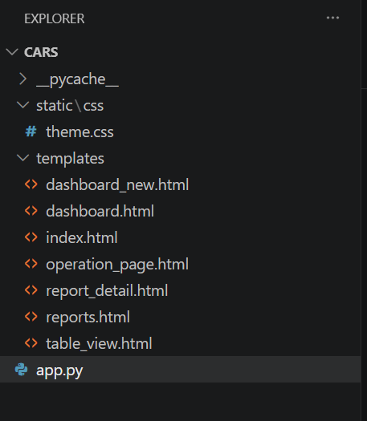
Image 19. New Project Structure in IDE
Database Connection Configuration (config.py):
import os
class Config:
DB_SERVER = os.getenv('DB_SERVER', 'DESKTOP-7H7TALB')
DB_NAME = os.getenv('DB_NAME', 'CarManufacturing')
DB_USER = os.getenv('DB_USER', '')
DB_PASSWORD = os.getenv('DB_PASSWORD', '')
DB_DRIVER = os.getenv('DB_DRIVER', 'SQL Server')
SECRET_KEY = os.getenv('SECRET_KEY', 'full_erp_secret')

Database Connection Helper (db.py excerpt):
import pyodbc
from .config import Config
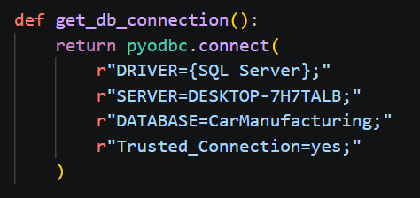
Image 20.Database Connection Helper

3.2. More Detailed Analysis
The application follows a Model-View-Controller (MVC) pattern, but since Flask is a microframework, the database access layer is implemented directly in helper functions rather than using an ORM.

<center>Image 19. List of main modules in the project.</center>
1. Data Access Layer (db.py)
The db.py module contains helper functions for executing SQL queries, calling stored procedures, and fetching data. Unlike the Java example with Spring Data JPA, this implementation uses pure SQL and pyodbc.
Key functions:
- get_db_connection() — establishes a connection to SQL Server
- execute_with_result() — executes a stored procedure and returns the result
- fetch_first_successful() — tries multiple queries and returns the first successful result
- rows_to_dicts() — converts pyodbc rows to dictionaries for easier template rendering
Example — calling a stored procedure:
def call_insert_purchase(cursor, material_id, quantity, amount, employee_id=2):
result = execute_with_result(
cursor,
"""
DECLARE @result INT;
EXEC dbo.sp_InsertPurchase
@MaterialID=?,
@Qty=?,
@Amount=?,
@EmpID=?,
@Result=@result OUTPUT;
SELECT @result AS Result;
""",
(material_id, quantity, amount, employee_id),
)
return int(result.get("Result", 1))

2. Controllers (app.py)
The app.py file contains all route handlers (controllers). Each route corresponds to a specific page or operation in the system.
Main routes:
Route | Method | Description
/ | GET | Dashboard with KPI cards
/buying | GET | Raw material purchase page
/production | GET | Production page
/sales | GET | Sales page
/finance | GET | Finance and loans page
/module2 | GET | Module 2 automatic requests page
/reports | GET | Reports hub
/buy | POST | Process a purchase
/produce | POST | Process production
/sell | POST | Process a sale
/sell/rollback/<id> | POST | Rollback a sale
/pay_salaries | GET | Pay all salaries
/loan | POST | Take a new loan
/loan/repay/<id> | POST | Repay a loan
/production-request | POST | Submit Module 2 request
Example controller — production route:
@app.route('/produce', methods=['POST'])
def produce():
conn = None
try:
prod_id = parse_positive_int(request.form.get("prod_id"), "product ID")
qty = parse_positive_int(request.form.get("qty"), "quantity")
conn = get_db_connection()
cursor = conn.cursor()
procedure_result = execute_with_result(
cursor,
"""
DECLARE @result INT, @cost MONEY;
EXEC dbo.sp_ProduceProduct
@ProductID=?,
@Quantity=?,
@EmployeeID=?,
@ProductionCost=@cost OUTPUT,
@Result=@result OUTPUT;
SELECT @result AS Result, @cost AS ProductionCost;
""",
(prod_id, qty, 4),
)
result = int(procedure_result.get("Result", 1))
production_cost = _to_number(procedure_result.get("ProductionCost"))
if result == 0:
conn.commit()
flash(f"Success: {qty} car(s) assembled.", "success")
elif result == 1:
conn.rollback()
flash("Production failed: not enough raw materials.", "danger")
elif result == 2:
conn.rollback()
flash(f"Production failed: not enough budget. Required: {production_cost:,.0f} KGS.", "danger")
else:
conn.rollback()
flash(f"Production failed. Code: {result}.", "danger")
except Exception as e:
flash(str(e), "danger")
finally:
if conn:
conn.close()
return redirect(url_for("production_page"))

3. Views (Templates)
The View layer uses Jinja2 templating with HTML, CSS (Bootstrap + custom theme), and JavaScript (Chart.js for reports).
Template structure:
- dashboard.html — main dashboard with KPI cards and quick navigation
- operation_page.html — generic template for buying, production, sales, finance, and module2 (switches via page_kind variable)
- table_view.html — displays tabular data (raw materials, employees, products, requests)
- reports.html — reports hub with summary cards and links to detailed reports
- report_detail.html — detailed report page with charts and data tables
Example — Dashboard KPI cards (dashboard.html excerpt):
<section class="metric-grid">
<a class="metric-tile" href="/finance">
<span>Current Budget</span>
<strong>{{ "{:,.0f}".format(budget).replace(",", " ") }}</strong>
<small>KGS available</small>
</a>
<a class="metric-tile" href="/table/materials">
<span>Warehouse</span>
<strong>{{ mat_count }} items</strong>
<small>raw materials</small>
</a>
<a class="metric-tile" href="/table/employees">
<span>Employees</span>
<strong>{{ emp_count }} staff</strong>
<small>factory team</small>
</a>
<a class="metric-tile" href="/table/products">
<span>Showroom</span>
<strong>{{ product_count }} models</strong>
<small>finished products</small>
</a>
</section>

Example — Production form (operation_page.html when page_kind = "production"):
{% if page_kind == "production" %}
<section class="photo-card">
<div class="photo-title">
<span class="photo-title-mark"></span>
<h1>Finished Product Production</h1>
</div>
<form action="/produce" method="POST" class="ops-form ops-form-panel">
<h2>Start production</h2>
<select name="prod_id" class="photo-input" required>
{% for p in products %}
<option value="{{ p[0] }}">{{ p[1] }}</option>
{% endfor %}
</select>
<input type="number" name="qty" min="1" placeholder="Quantity" class="photo-input" required>
<button class="photo-btn photo-btn-wide">Produce</button>
</form>
</section>
{% endif %}

4. Module 2 — Production Request Automation
The most advanced feature of the application. When a user submits a production request, the system:
- Checks raw material availability using the BOM.
- If materials are insufficient, calculates shortages.
- Checks if the budget has enough funds for procurement.
- Automatically creates purchase orders for missing materials.
- Receives the purchased materials into stock.
- Runs the production process.
- Creates a sale with a 30% markup over production cost.
- Updates the request status at each stage.
- On failure, records the error stage and reason.
Request processing logic (app.py excerpt):
@app.route('/production-request', methods=['POST'])
def production_request():
# ... validation ...
# 1. Check recipe
recipe = get_product_recipe(cursor, prod_id, qty)
# 2. Identify missing materials
missing_materials = [...]
# 3. If missing, create purchases
if missing_materials:
procurement_cost = sum(item[4] for item in missing_materials)
if budget < procurement_cost:
raise ValueError(f"Insufficient budget. Required: {procurement_cost} KGS.")
for material_id, name, missing_qty, unit_cost, missing_cost in missing_materials:
call_insert_purchase(cursor, material_id, missing_qty, missing_cost)
# 4. Run production
production_result = execute_with_result(cursor, "...", (prod_id, qty, 4))
# 5. Create sale with 30% markup
sale_amount = round(production_cost * 1.3, 2)
cursor.execute("INSERT INTO Product_Sales ...", (prod_id, qty, sale_amount))
# 6. Update request status to 'Completed'

Request statuses:
- Created — initial state
- Under raw material availability check — checking BOM and stock
- In the process of raw material procurement — purchasing missing materials
- In the production process — manufacturing products
- In the sales process — selling finished products
- Completed — workflow finished successfully
- Error — failed with a reason stored in Rejection_Reason

4. Launching the Program
To launch the project locally, you need to:
- Open the project folder in PyCharm or VS Code.
- Make sure that MSSQL database CarManufacturing exists on your SQL Server instance and the connection settings in config.py are correct.
- Install dependencies: pip install -r requirements.txt
- Run the application: python app.py
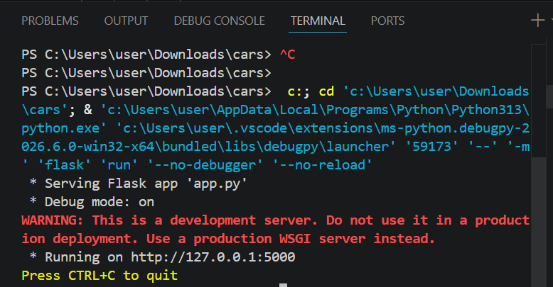
Image 21. Running the application in terminal
The project is launched locally from the terminal. After starting the Flask application, the web application becomes available in the browser on the default port 5000.
- After the application starts successfully, open a web browser.
- Open the application URL: http://127.0.0.1:5000
- Start working with the system.

5. Screenshots of the Program
Main Page / Dashboard
When launching the application, the user is greeted with the main page - Dashboard with KPI cards (current budget, warehouse items, employees, showroom models) and a sidebar, which contains the most necessary data (current budget, list of available pages, etc.).
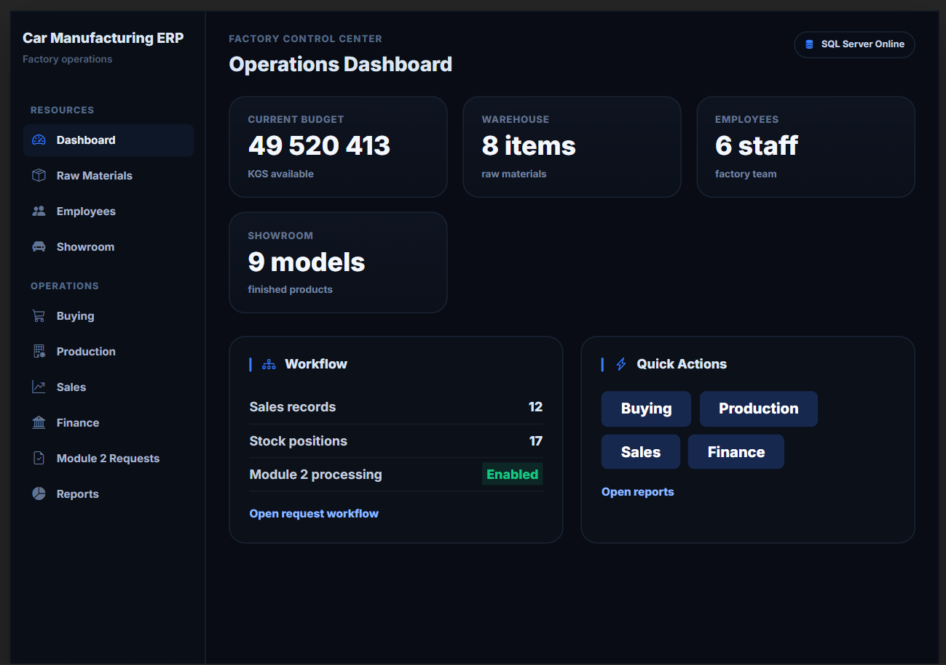
Image 22. Main Dashboard page.
Using the web application, you can directly change all the necessary data such as budget, existing positions and employees, raw materials, ingredients and finished products.
You can also carry out enterprise operations: purchase raw materials, produce products, sell products, pay salaries to employees and take loans.
For example, the company is launching a new car model - an electric vehicle "Lightning" (conditionally 100 units per batch). In this case, in addition to the general raw materials such as steel, tires and paint, it will be necessary to add new types of raw materials - lithium-ion batteries and electric motors.
1. The employee goes to the page "Raw Materials" and adds all the necessary materials
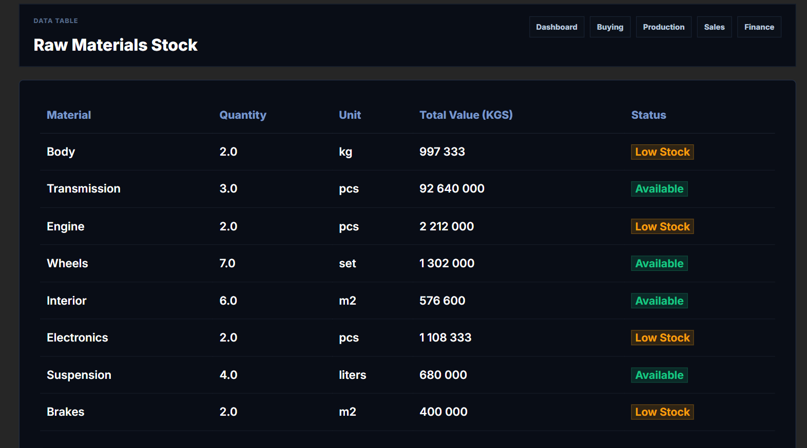
Image 23. Raw Materials page / new materials added
2. Then the employee needs to purchase the raw materials, so he goes to the "Buying" page and buys all necessary materials.
Don't forget to check the Budget!
Each purchase will take the cost of raw materials from the company's budget. If the budget is not enough, production can apply for a credit (loan), but this will happen later.
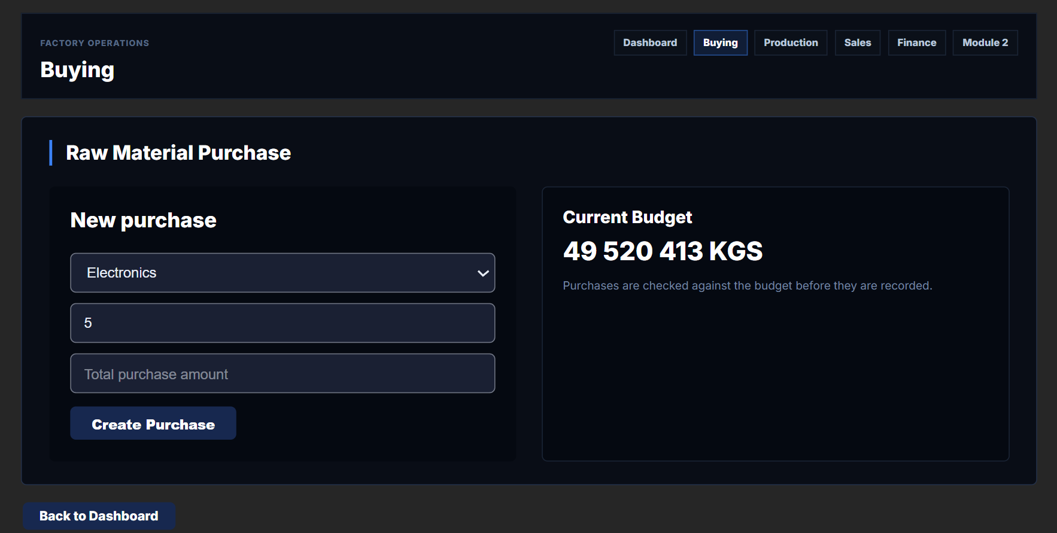
Image 24. Buying page / purchasing raw materials
Image 25. Purchase confirmation / purchases added
3. The employee creates all other necessary records, creating a new type of product that will be produced
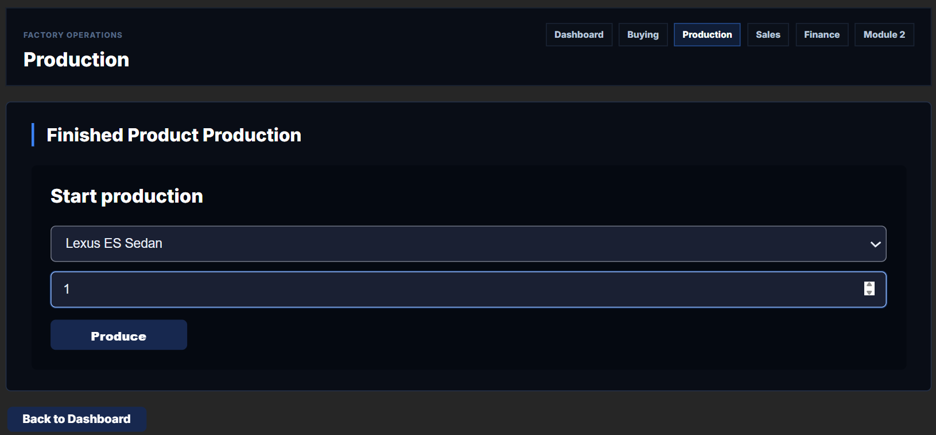
Image 26. Finished Products
Image 27. new car model added
<center>Image 26. Finished Products / Showroom page / new car model added</center>
4. After creating a product, you can see all produced cars in showroom
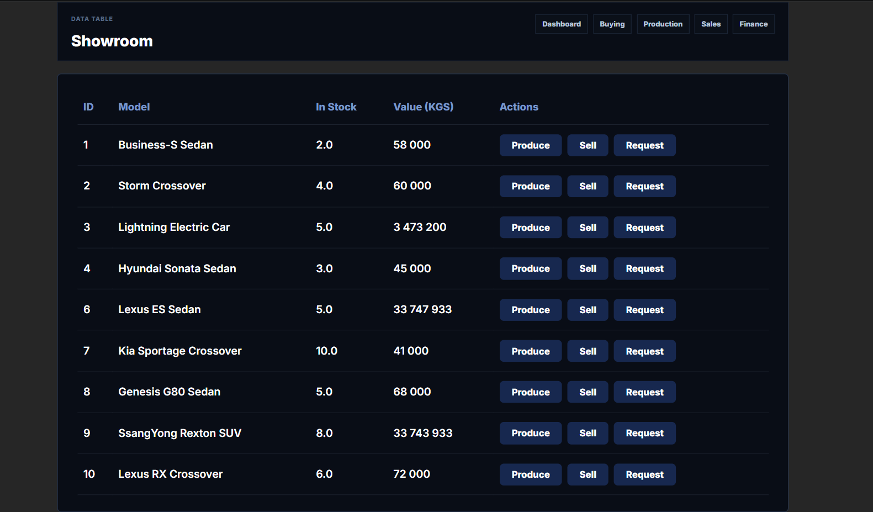
Image 28. Showroom page
5. Now the last part is to sell the produced product
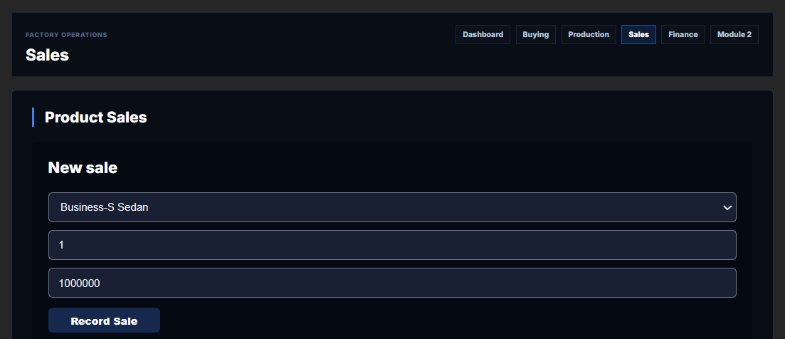
Image 29. Sales page
Image 30. Sold product
But if you try to sell the product and there is insufficient stock, the error page will be shown.
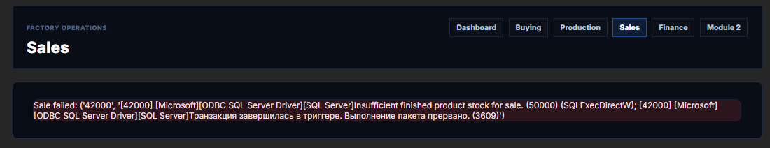
Image 30. Error message / insufficient stock
So in order not to lose a sale, you need to make sure there is enough finished product in stock.
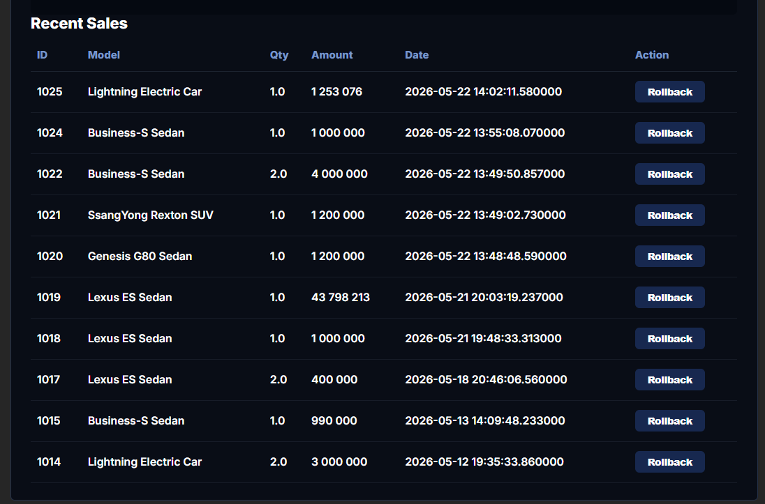
6. Finance, Payroll and Loans
If the budget is insufficient for purchasing raw materials or production, the company can take a loan. Each loan increases the budget by the loan amount.
The company can pay salaries to all employees at once.
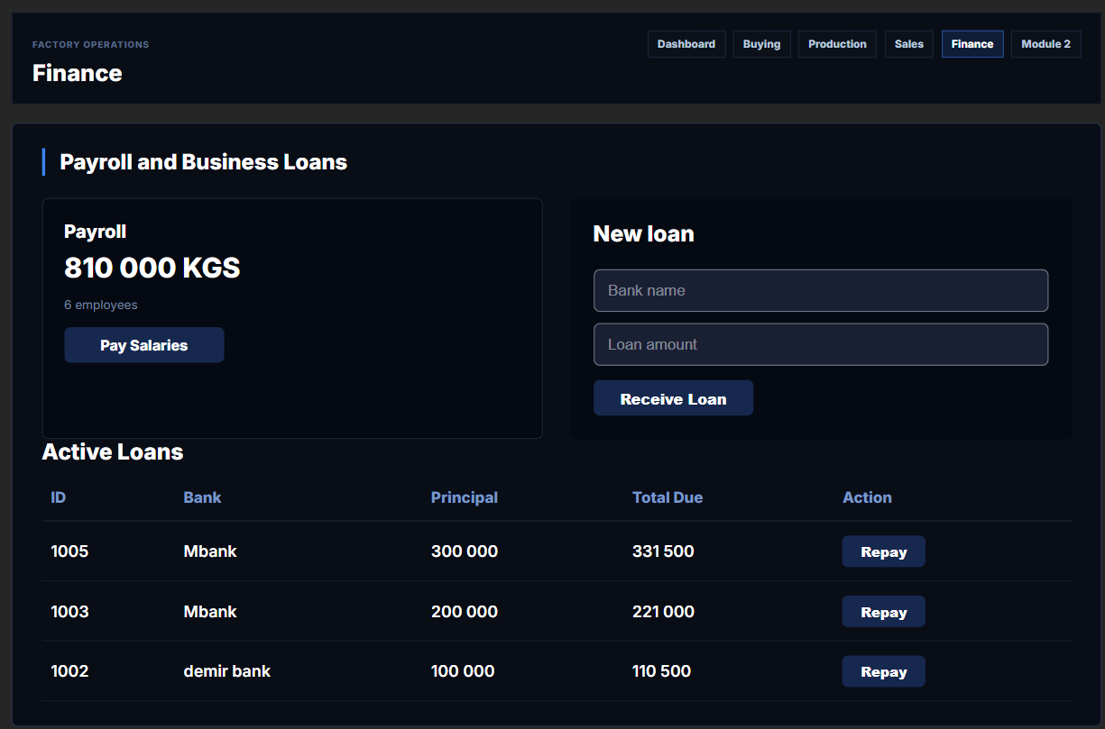
Image 31. Finance page — payroll and loans
7. Module 2: Automatic Production Request
The user submits a production request. The system checks raw material availability. If materials are insufficient, it automatically creates purchase orders for missing materials (if budget allows), then runs production, and creates a sale with a 30% markup.
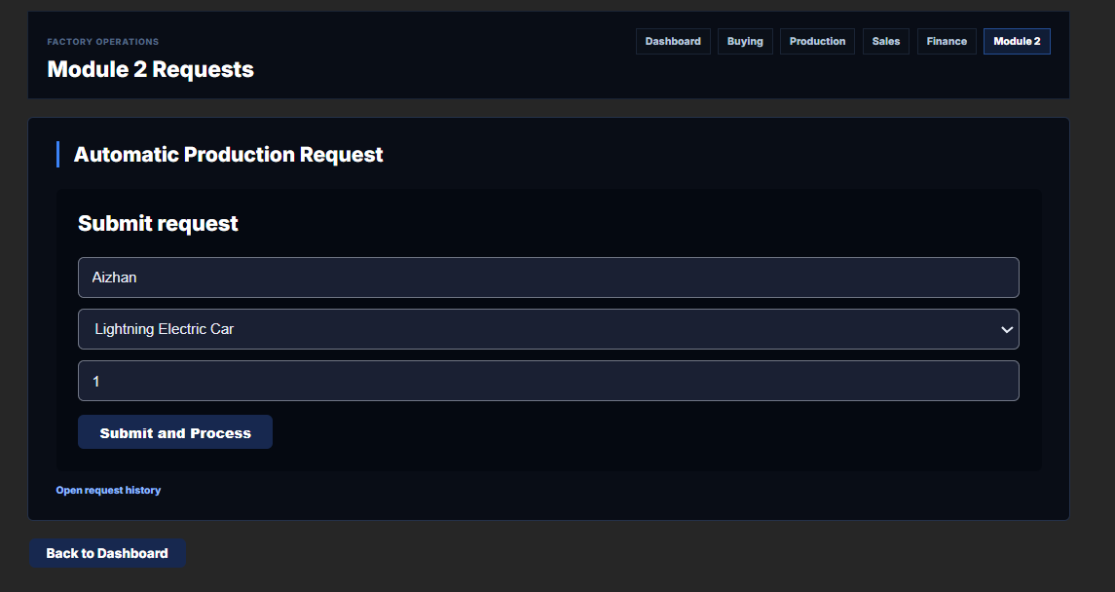
Image 32. Module 2 / submitting a production request
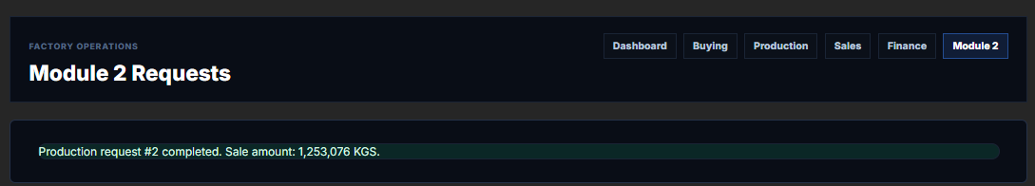
Image 33. Module 2 / request processing status
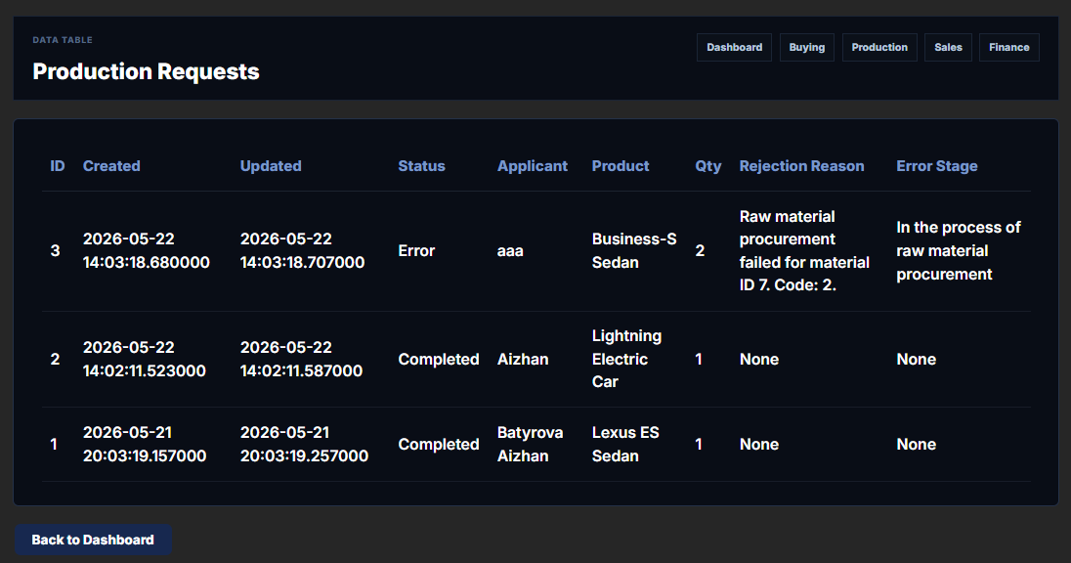
Image 34. Module 2 /Production Request
If raw materials are missing and budget is insufficient for procurement, the request receives "Error" status with a clear rejection reason.
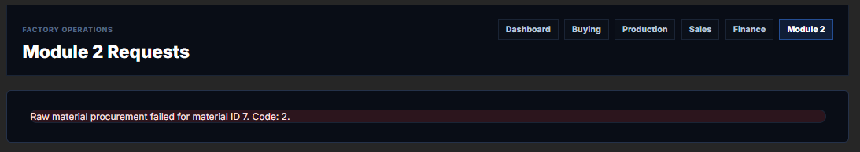
Image 34. Error in Module 2

8. When opening the Dashboard page again, the user is greeted with recent changes and actions in the system
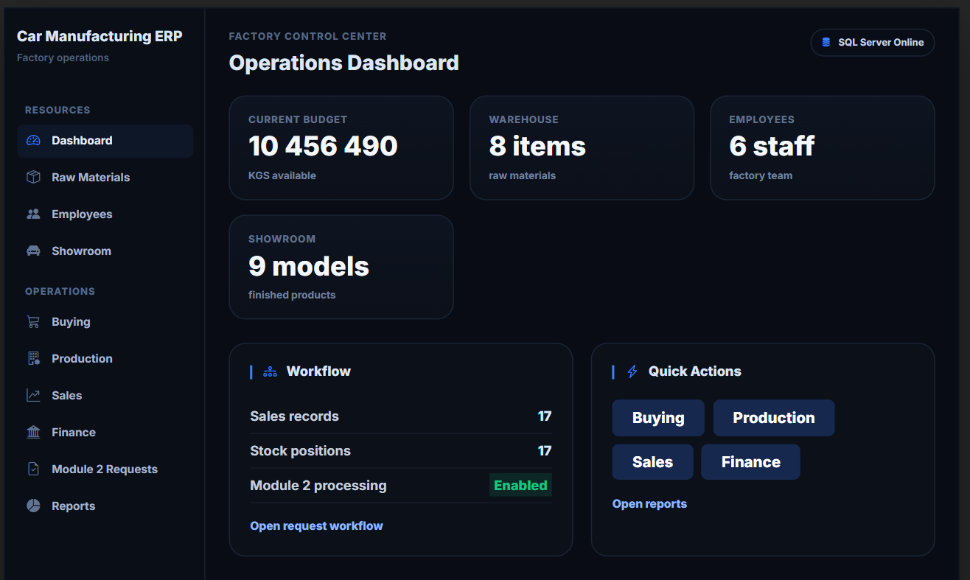
Image 37. Dashboard page / updated after operations
9. Reports Hub (Lab 6)
In the program, on the Reports Hub page, it is possible to view aggregated reports which contain a history and minimalistic diagrams for each business operation: production, sales, payroll, and loans.
The Reports Hub page shows key performance indicators: total cars produced (38 units), total revenue (81,591,289 KGS), salary payouts (10,530,000 KGS), and active loans (3 loans requiring repayment).
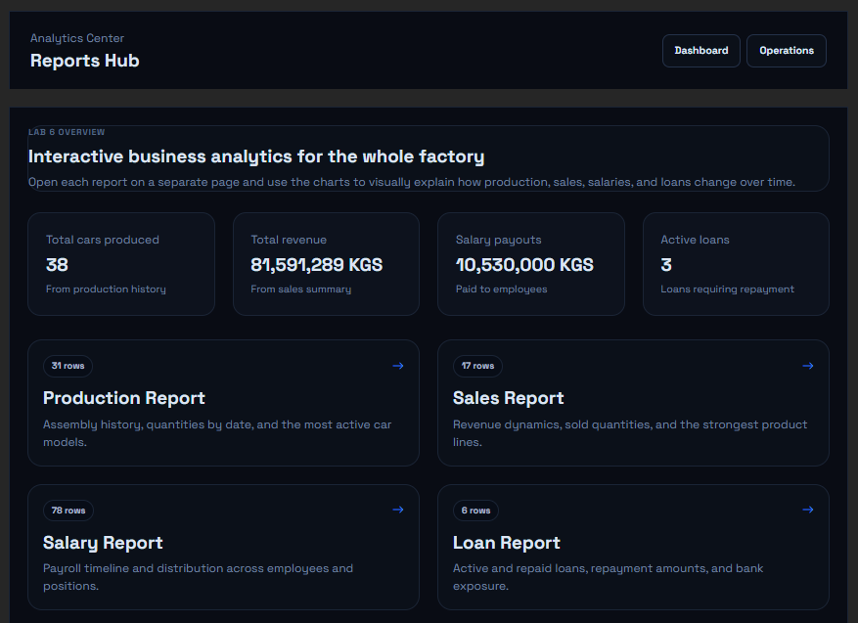
Image 38. Reports Hub — main analytics page
Production Report shows how many cars were assembled by date and by model. The production dynamics chart displays the number of cars assembled over time, while the bar chart shows which models are assembled most often (Business-S Sedan, Lightning Electric Car, Storm Crossover, Lexus ES Sedan, SaengYong Redox SUV). The detailed table contains production records with date, model, quantity, and responsible employee.
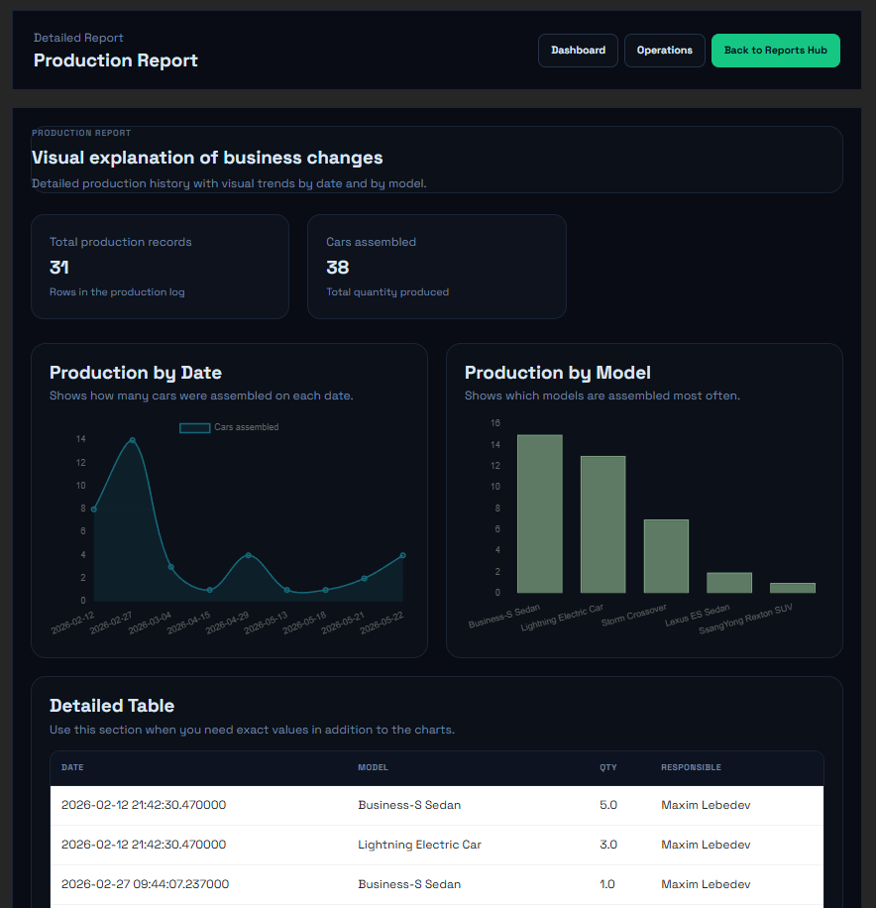
Image 39. Production Report — production history with chart
Sales Report shows revenue dynamics and sold quantities by model. The revenue chart displays how sales revenue changes over time (reaching 45,000,000 KGS), while the bar chart shows which car models are sold most often. The detailed table contains sales records with date, car model, sold quantity, revenue, and sales manager.
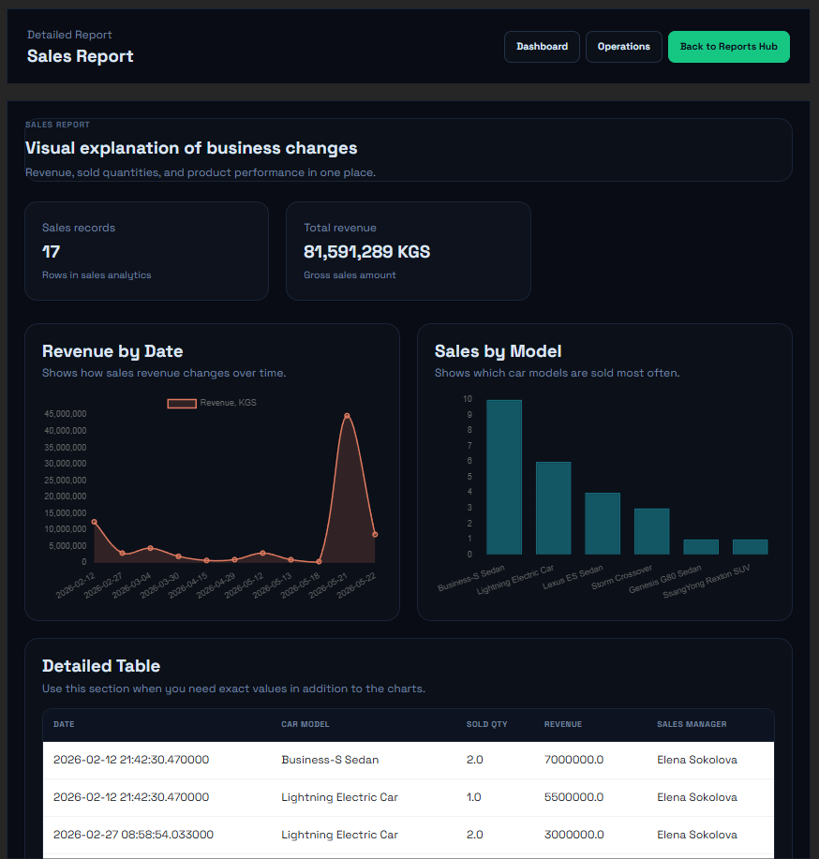
Image 40. Sales Report — revenue chart and sales table
Salary Report shows payroll timeline and distribution across employees. The payroll chart displays how much money was paid on each payroll date, while the bar chart shows the largest salary totals by employee (Peter Ivanov, Olga Kuznetsova, Maxim Lebedev, Anna Smirnova, Elena Sokolova, Dmitry Popov). The detailed table contains payment records with date, employee, position, and amount.
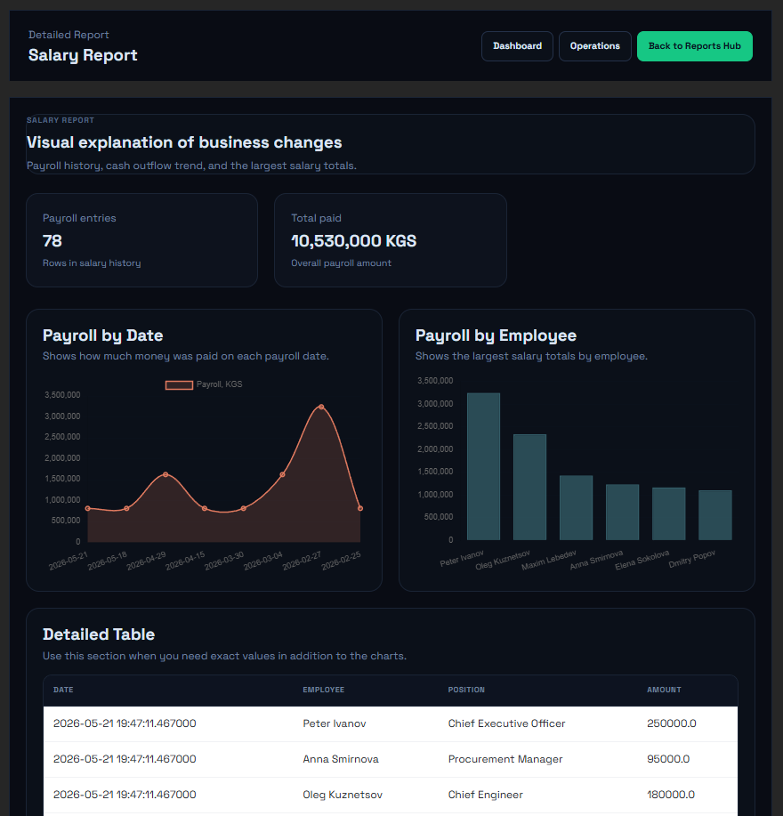
Image 41. Salary Report — payroll chart and payment history
Loan Report shows active and repaid loans with repayment amounts. The bar chart shows which banks provided the largest loans (Demir Bank, Mbank), while the doughnut chart shows the distribution of loan statuses (Active vs Repaid). The detailed table contains loan records with ID, bank, loan amount, interest rate, date, status, and total due.
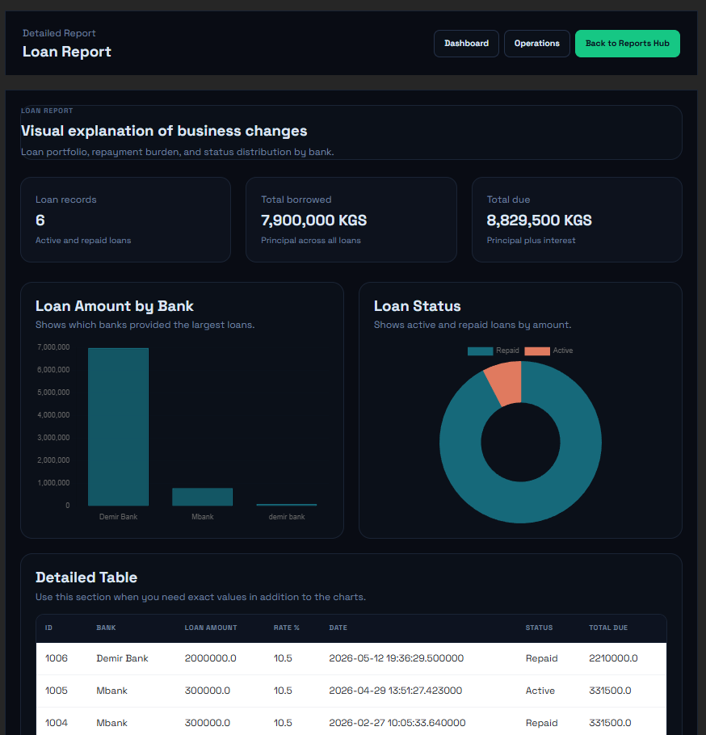
Image 42. Loan Report — loan portfolio chart and status
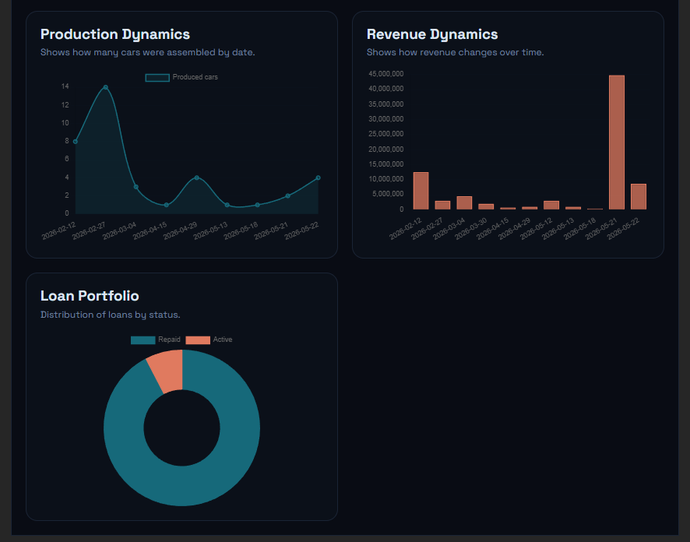
Image 43. Example of report diagram on production dynamics
6. Conclusion
During the development of this web application as part of the course project, I gained valuable experience working with the Flask framework, the Python programming language, and Microsoft SQL Server. I significantly improved my skills in database design and in writing T-SQL stored procedures, triggers, and scalar functions to enforce business rules directly at the database level.
The server side was implemented in Microsoft SQL Server using SQL Server Management Studio, with 13 tables, 5 stored procedures, 1 scalar function, and 2 triggers. The client side was built with Python and Flask (MVC pattern) using PyCharm as the development environment. The project made extensive use of pyodbc for database connectivity, Jinja2 templates for dynamic views, and Bootstrap 5 for responsive UI design.
This course project demonstrated the full database management cycle — from requirements analysis and schema design to stored procedure implementation and web interface development. The result is a fully functional enterprise management system that can be extended for real-world use.

7. List of Used Literature
- Flask Documentation. Flask Web Framework — Official Documentation. URL: https://flask.palletsprojects.com/ (accessed: 15.05.2026).
- Microsoft Corporation. SQL Server Documentation — CREATE PROCEDURE (Transact-SQL). URL: https://docs.microsoft.com/en-us/sql/t-sql/statements/create-procedure-transact-sql (accessed: 15.05.2026).
- Microsoft Corporation. SQL Server Documentation — CREATE TRIGGER (Transact-SQL). URL: https://docs.microsoft.com/en-us/sql/t-sql/statements/create-trigger-transact-sql (accessed: 15.05.2026).
- Grinberg M. Flask Web Development: Developing Web Applications with Python. — O'Reilly Media, 2018. — 316 p.
- Ben-Gan I., Sarka D., Talmage R. T-SQL Fundamentals. — Microsoft Press, 2016. — 464 p.
- Bootstrap Documentation. Bootstrap v5.0 — CSS Framework. URL: https://getbootstrap.com/docs/5.0/ (accessed: 15.05.2026).
- Chart.js Documentation. Simple yet flexible JavaScript charting library. URL: https://www.chartjs.org/docs/latest/ (accessed: 15.05.2026).
- pyodbc Documentation. Python ODBC bridge for SQL Server. URL: https://github.com/mkleehammer/pyodbc/wiki (accessed: 15.05.2026).
- Training documents of the "Software of computer systems" department, Kyrgyz State Technical University named after I. Razzakov.

8. Application Appendix
In this appendix, additional file codes are provided that may be useful for a more complete acquaintance with the project.
Appendix A. Full app.py Structure
The main application file contains all route handlers and helper functions. Key functions include:
- get_db_connection() — database connection
- execute_with_result() — stored procedure execution
- load_production_requests() — Module 2 request loader
- get_product_recipe() — BOM loader
- call_insert_purchase() — purchase procedure wrapper
- Chart building functions (aggregate_series, aggregate_categories, make_chart)
- Report loaders (load_production_report, load_sales_report, load_salary_report, load_loans_report)
- All route handlers (dashboard, buying, production, sales, finance, module2, reports, and their POST handlers)
Appendix B. Database Schema (Full DDL)
The complete database schema includes:
- 13 tables with primary keys and foreign keys
- 5 stored procedures
- 1 scalar function
- 2 triggers
Appendix C. Sample Data (INSERT statements)
Initial data includes:
- Suppliers (МеталлИнвест, АвтоКомплект, Шинный Мир, Электро-Деталь)
- Raw materials (steel, engines, tires, leather, paint, batteries)
- Products (Sedan Business-S, Crossover Storm, Electric Lightning)
- Employees with positions and salaries
Appendix D. Module 2 Complete Workflow Code
The full implementation of sp_submit_production_request and sp_process_production_request logic, which orchestrates procurement, production, and sale in one atomic workflow.

